**QuickStart**

## Glossary

*Zap Actions*: Each user interaction on Desktop recorded by Zap is termed as a Zap Action.

*Zap Task / Activities*: A group of Zap Actions that can be grouped to form a Zap Task.

*Zap Window:* One can find “Z” icon besides Minimize, Maximize and Cancel buttons.

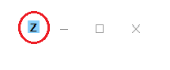

## 1.1 Global Shortcuts

Once Zap is running, user can use the below Keyboard shortcuts (on any window) in order to.

|  |  |
| --- | --- |
| Keys Combination | Description |
| Ctrl + Alt + S | Start/Stop Learning New Actions and create a Zap Task |
| Ctrl + Alt + Z | Execute First Displayed Zap Task |
| Ctrl + Alt + K | Cancel Execution of a Zap Task |
| Ctrl + Alt + E | Export Last Learned Zap Task |

## 1.2 Start Zap

Just double click on the Zap Application Icon from the desktop and it will be started for you after installation. It automatically starts at subsequent system startups.

**Zap Icon** appears as a taskbar Icon in notification area (bottom right corner of Windows Taskbar) or clicking the Chevron (^) Icon if it is hidden.

 or 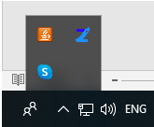

### 1.2.1 Zap Context Menu can be accesses by right clicking on Zap Icon.

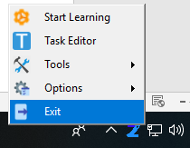

### 1.2.2 Start/Stop Learning

Zap can Capture and Save user desktop interactions collected between “Start Learning” and “Stop Learning” commands using Keyboard Shortcut ‘**Ctrl + Alt + S’**.

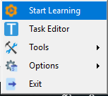

Alternatively, these commands (Start / Stop Learning) can be invoked from the Zap Context Menu.

You can create a Zap Task by invoking *Start Learning* command and then doing a particular set of actions on the desktop. Upon completing the set of desired actions, you can invoke the *Stop Learning* command.

A Zap window and a Zap Task (“*Learned Activities*”) will appear on the window on which user performed first action following the Start Learning command.

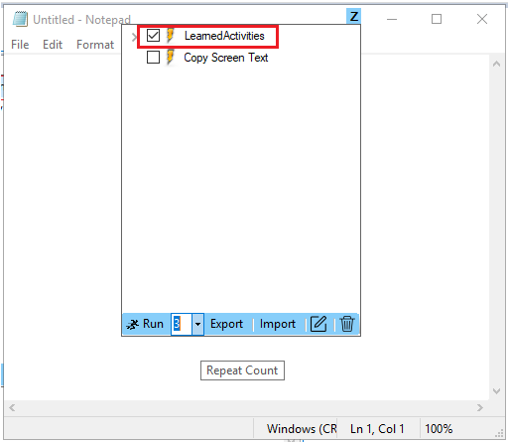

### 1.2.3 Execute Zap Task / Activities

You can perform these Activities again by **Double Clicking** the Activity or selecting the Activity and clicking **Run** button in Zap Window.

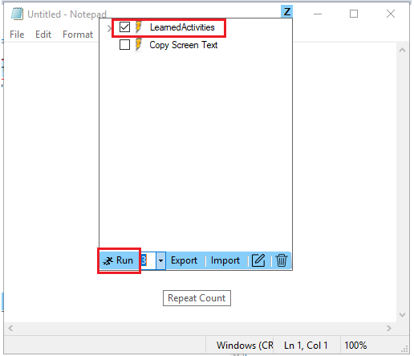

### 1.2.4 Repeat / Iterate Same Activity ‘Any’ number of times

You can repeat the *Learned Activities* by selecting the Activity (ticking the checkbox), typing the *Repeat Count* and clicking the **Run** Button.

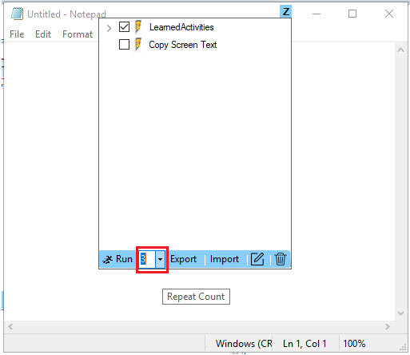

### 1.2.5 Rename Activity

You can **Rename** a *Learned Activity* to a name of your choice by clicking on an activity – pausing and then clicking again (just like renaming a File in Windows Explorer). These activities are persisted on a per Application per Window Title basis.

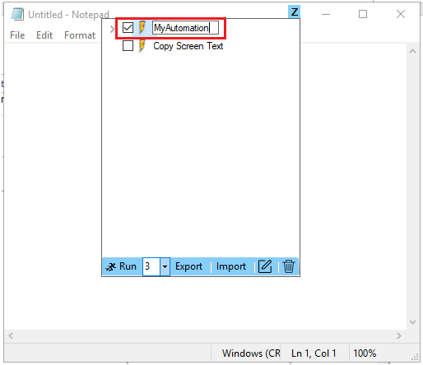

### 1.2.6 Export / Import / Delete Activity

You can Export / Import / Delete the *Learned Activities* by selecting the Activity (ticking the checkbox) and clicking the **Export / Import / Delete** Button.

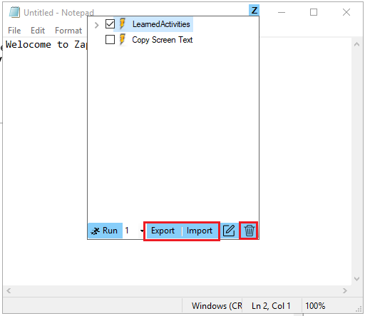

### 1.2.7 Open in Zap Task Editor

You can open the *Learned Activities* in the Task Editor by selecting the Activity (ticking the checkbox) and clicking the **Task Editor Icon** ().

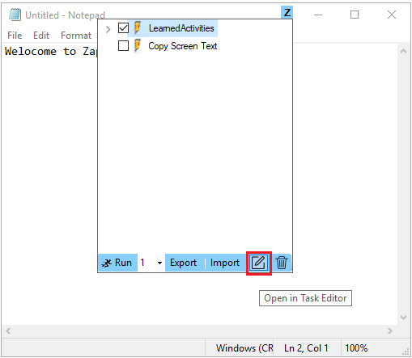

## 1.3 Zap Task Editor

Zap Task Editor can be started from the Zap Context Menu or by clicking the Open in Task Editor button on the Zap window

Zap Task editor allows you to manage workflows and add validation actions. Task Editor is our powerful and user-friendly automation canvas, is an essential component in the Zap. It features a rich collection of pre-built activities, integrates with several programming languages, and promotes ease-of-use, scalability, and efficiency.

### 1.3.1 Automate Faster

Create automations with our drag and drop, code-free, editor. Leverage our library of hundreds of activities and pre-built automation components. For fast and easy troubleshooting our visual debugger highlights an exact error and displays easy to comprehend messages.

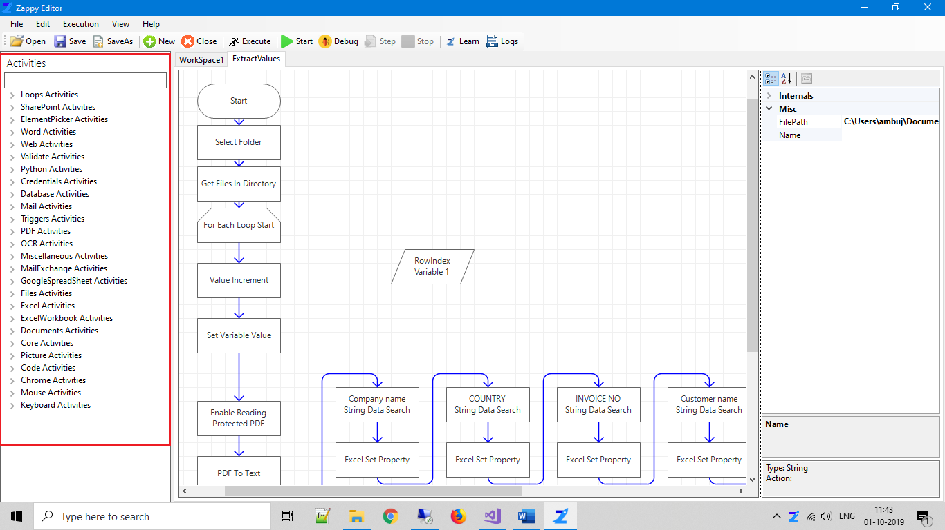

### 1.3.2 Automate Smarter

No more manual, error-prone programming of each process step and user action, Zap learns your actions and build them into an automation workflow.

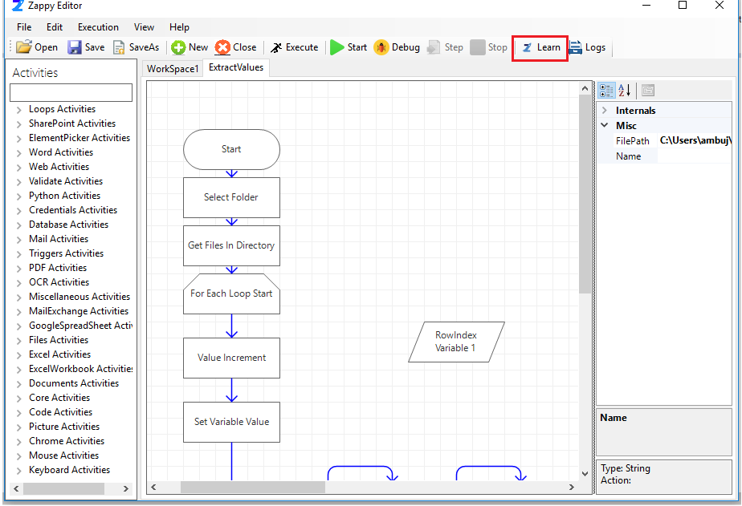

### 1.3.3 Automate Together

No need to invent the wheel. Share and reuse ready-made automation components from Editor’s extensible libraries and save on development time and cost. Build reusable components with Zap to collaborate, standardize, and work on automation best practices within your organization and with fellow developers for the most effective results.

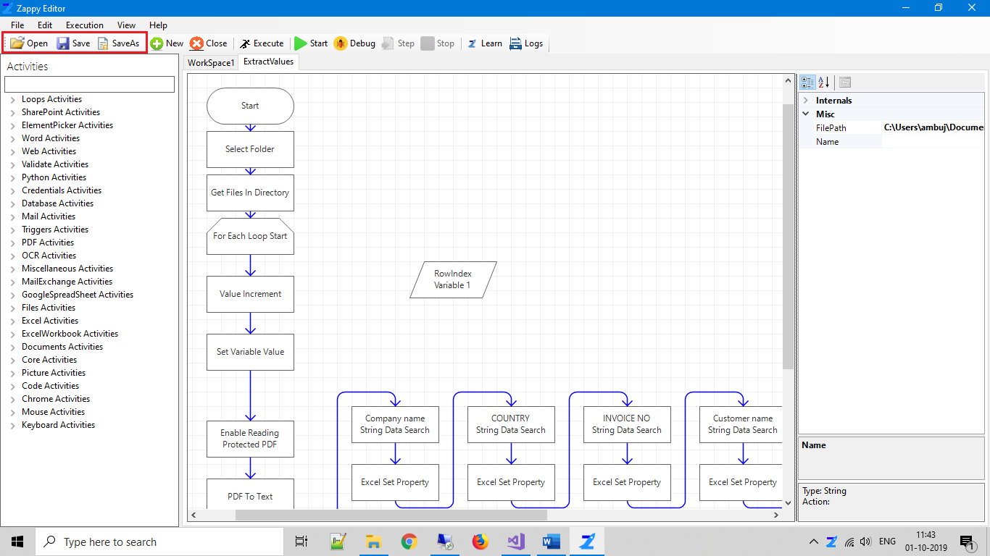

## 1.4 Zap Logger

Zap generates audit logs which can be accessed by Zap Logger. They capture events which can show “who” did “what” activity and “how” the system behaved.

Zap Logger can be started from the Zap Context Menu or Zap Task Editor.

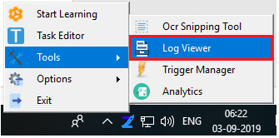 or 